REGULAR MEETING
JANUARY 15, 2026

The Regular Meeting of the Town Board of the Town of Hampton, County of Washington and the State of New York was held at the Town Hall, 2629 State Route 22A, Hampton, New York, on the 15th day of January 2026.

PRESENT: David K. O’Brien-----------Supervisor
Donald Sady---------------- Councilman
Tamme Taran---------------Councilwoman
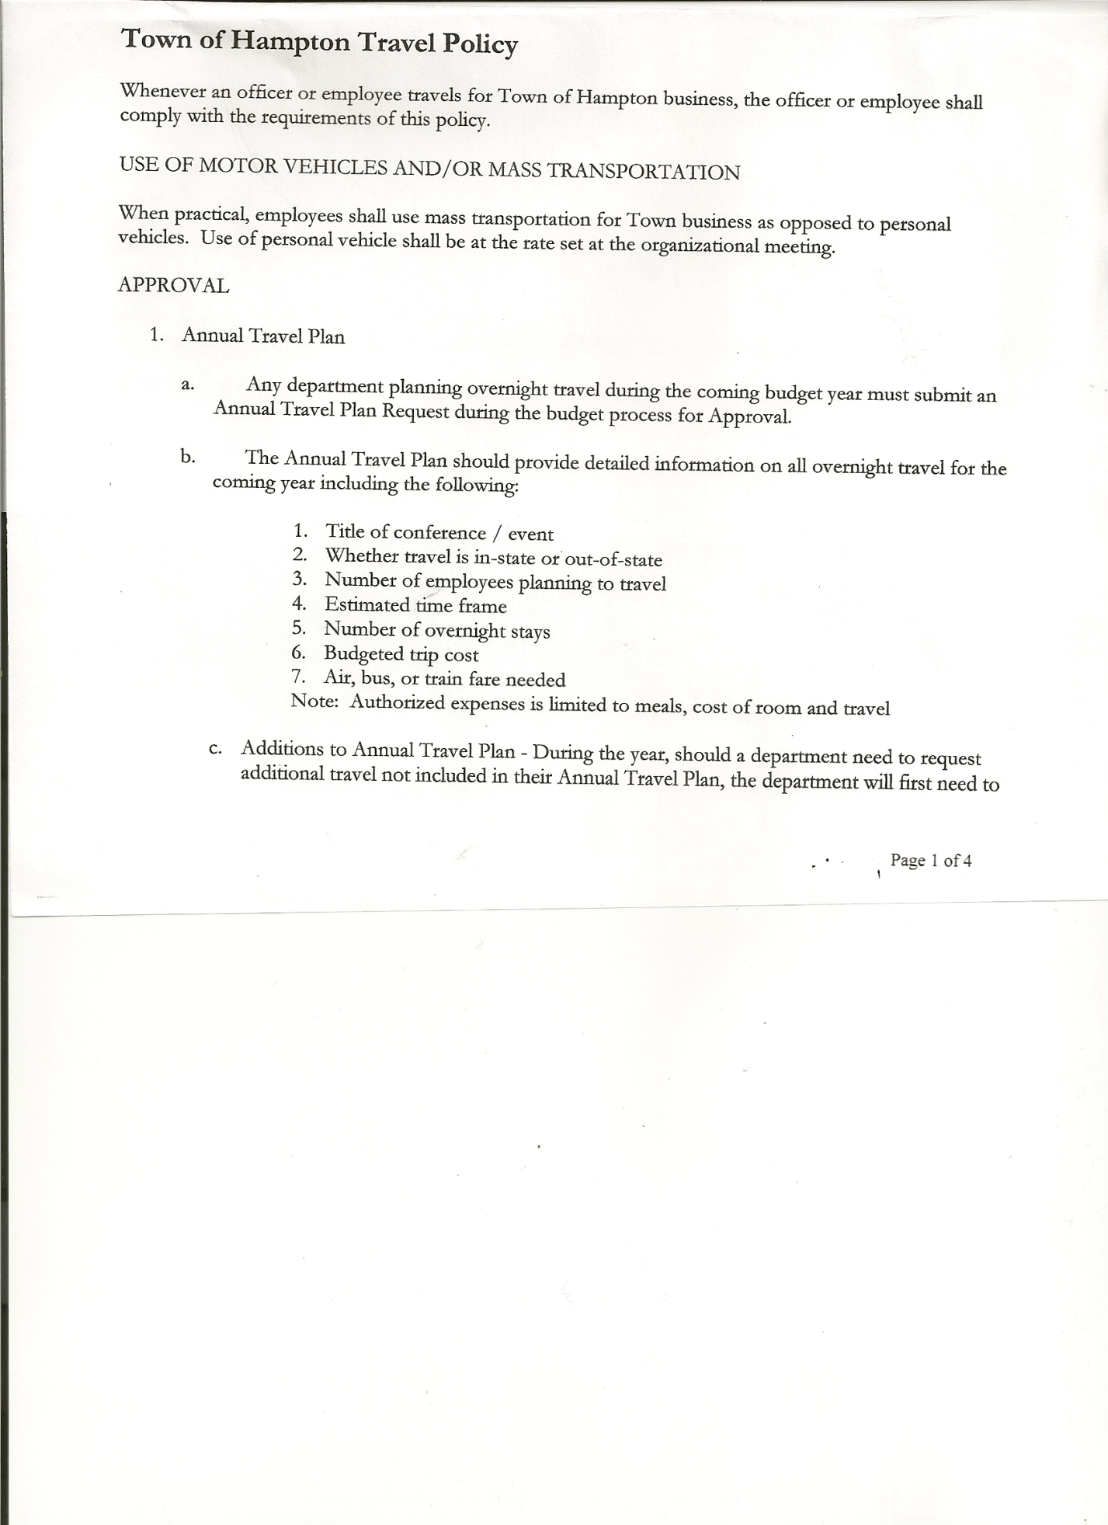
Michael Pietryka------------Councilman
Bradley Perry --------------Councilman
Rebecca Jones---------------Town Clerk
Camilla Shaw----------------Deputy Town Clerk
Tyler McClure---------------Highway Superintendent - absent

Planning Board Member (s):… Bonnie Hawley, Chair, and Matthew Pratt
Others present at the Town Hall: EJ Conzola (NY/VT Media Reporter), Artie Pratt, Faith Fernald-Sears and Hampton Sears.

The Regular Meeting was called to order by Supervisor O’Brien at 7:30pm, followed by the Pledge of Allegiance. Location of Fire Exits was given. Quorum of board members present.

Supervisor O’Brien asked for a moment of silence in memory of Barbara Lussier

RESOLUTION NO. 9-2026
APPROVAL OF THE MINUTES
On a motion of Councilwoman Taran, seconded by Councilman Perry, the following resolution
was ADOPTED: AYES 5 O’Brien, Sady, Pietryka, Taran, Perry
NAYS 0
RESOLVED, the Regular Town Board Meeting Minutes for December 18, 2025 and the Special Town Board Meeting Minutes (Organizational Meeting of 2026) for January 2, 2026 are approved.

Dog Control Officer…..no report

Tax Collector Report….Tax bills were sent out at the end of December 2025. As of this meeting, January 15th, amount collected was $162,656.60. The Town Clerk/Collector had Board Members review and sign bank reconciliation statements for the Tax Collector Account dated December 31st, 2025. Tax Collector End of Year Report for 2025 was submitted to Board members for their review and signatures.

Bonnie Hawley, Chair Planning Board….Planning Board members are working on Battery Storage law. Next meeting will be February 11, 2026 @7:00 at the Town Hall.

Tyler McClure, Highway Superintendent…Supervisor O’Brien read Tyler’s report in his absence, copy attached.

TOWN BOARD MEETING
JANUARY 15, 2026 PAGE 2

SUPERVISOR’S REPORT/COUNTY UPDATES/COMMUNICATIONS

RESOLUTION NO. 10-2026
BUDGET MODIFICATIONS-HIGHWAY FUND
On a motion of Councilman Sady, seconded by Councilwoman Taran, the following resolution
was ADOPTED: AYES 5 O’Brien, Sady, Pietryka, Taran, Perry
NAYS 0
RESOLVED that, the following Budget Amendments to the Highway Fund are approved:
Increase Interest Capital Reserve Account #DA2401.2 in the amount of $15,671.18
Increase Miscellaneous Income Account #DA2770 in the amount of $36,006.00
Increase Scrap Metal Account #DA2650 in the amount of $4,600.00

Increase Machinery CE Account #DA5130.4 in the amount of $9,330.30
Increase State Retirement Account #DA9010.8 in the amount of $10,682.63
Increase Uniforms Account #DA9089.8 in the amount of $757.55
Increase Capital Project Fund Account #DA9950.9 in the amount of $70,000.00

Decrease Capital Outlay Account #DA5112.2 in the amount of $66,160.69
Decrease General Repairs Account #DA5110.4 in the amount of $24,609.79

RESOLUTION NO. 11-2026
BUDGET MODIFICATIONS-GENERAL FUND
On a motion of Councilman Sady, seconded by Councilman Perry, the following resolution
was ADOPTED: AYES 5 O’Brien, Sady, Pietryka, Taran, Perry
NAYS 0
RESOLVED that, the following Budget Amendments to the General Fund are approved:
Increase Other Payments in Lieu of Taxes Account #A1081 in the amount of $ .30
Increase Interest & Penalties on Real Property Taxes Account #A1090 in the amount of $62.04
Increase Clerk Fees Account #A1255 in the amount of $ 401.02

Increase Justice CE Account #A1110.4 in the amount of $1,034.00
Increase Justice PS Account #A1110.1 in the amount of $ .34
Increase Town Clerk PS Account #A1410.1 in the amount of $895.68
Increase Central Printing & Mailing CE Account #A1670.4 in the amount of $3,171.34
Increase Unallocated Insurance Account #A1910.1 in the amount of $283.54
Increase Municipal Association Dues Account #A1910.2 in the amount of $536.00
Increase Control of Dogs CE Account #A3510.4 in the amount of $207.66
Increase Superintendent of Highways CE Account #A5010.4 in the amount of $16.99
Increase Social Security Account #A9030.8 in the amount of $120.26
Decrease Registrar of Vital Statistics PS Account #A4020.1 in the amount of $200.00

TOWN BOARD MEETING
JANUARY 15, 2026 PAGE 3

RESOLUTION NO. 12-2026
APPROVAL OF THE SUPERVISOR’S MONTHLY REPORT
On a motion of Councilman Sady, seconded by Councilwoman Taran, the following resolution
was ADOPTED: AYES 5 O’Brien, Sady, Pietryka, Taran, Perry
NAYS 0
RESOLVED that, the Supervisor’s Monthly report be accepted as amended and submitted for DECEMBER.
ACCOUNT 12/01/25 Receipts Disbursed 12/31/25
Citizens Cemetery $ 3,030.98 $ .13 $ 9.49 $ 3,021.62
Citizens Total $ 3,030.98 $ .13 $ 9.49 $ 3,021.62

GFNB Fire, Trust & Agency $ 1,000.41 $ 32,859.00 $ 33,859.41 $ 0.00
GFNB Fire, Trust & Agency ICS $ 32,859.00 $ 0.00 $ 32,859.00 $ 0.00
GFNB Health Insurance $ 2,591.23 $ 100.00 $ 100.00 $ 2,591.23
GFNB Trust & Agency $ 3,390.30 $ 4,156.84 $ 4,156.84 $ 3,390.30
GFNB General Fund $ 6,793.47 $ 8,984.85 $ 14,568.54 $ 1,209.78
GFNB General Fund ICS $ 49,180.17 $ 139.23 $ 6,500.00 $ 42,819.40
GFNB Total $ 95,814.58 $ 46,239.92 $ 92,043.79 $ 50,010.71

GFNB Highway Fund $ 37,694.31 $ 44,923.83 $ 80,408.45 $ 2,209.69
GFNB Highway Fund ICS $ 122,357.07 $ 369.79 $ 9000.00 $ 113,726.86
GFNB Capital Reserve $ 2,217.52 $ 33,000.00 $ 33,000.00 $ 2,217.52
GFNB Capital Reserve ICS $ 138,346.30 $ 33,558.96 $ 0.00 $ 171,905.26
GFNB Total $ 300,615.20 $111,852.58 $122,408.45 $ 290,059.33

TOTALS $399,460.76 $158,092.63 $214,461.73 $ 343,091.66
All Board Members present signed Supervisor’s Report.

OLD BUSINESS
Employee Handbook….Supervisor O’Brien has updated the Employee Handbook.
RESOLUTION NO. 13-2026
EMPLOYEE HANDBOOK
On a motion of Councilwoman Taran, seconded by Councilman Perry, the following resolution
was ADOPTED: AYES 5 O’Brien, Sady, Pietryka, Taran, Perry
NAYS 0
RESOLVED to, accept the updated Employee Handbook.

NEW BUSINESS

RESOLUTION NO. 14-2026
END OF YEAR AUDIT FOR TOWN CLERK and TAX COLLECTOR
On a motion of Councilwoman Taran, seconded by Councilman Perry, the following resolution
was ADOPTED: AYES 5 O’Brien, Sady, Pietryka, Taran, Perry
NAYS 0
RESOLVED, to accept the Town Clerk and Tax Collector Audits for 2025.

TOWN BOARD MEETING
JANUARY 15, 2026 PAGE 4

RESOLUTION 15-2026
END OF YEAR COURT AUDIT
On a motion of Councilman Sady, seconded by Councilwoman Taran, the following resolution
was ADOPTED: AYES 5 O’Brien, Sady, Pietryka, Taran, Perry
NAYS 0
RESOLVED, to accept the Court Audit for 2025.

RESOLUTION NO. 16-2026
AUDIT OF CLAIMS
On a motion of Councilwoman Taran, seconded by Councilman Sady the following resolution
was ADOPTED : AYES 5 O’Brien, Sady, Pietryka, Taran, Perry
NAYS 0
RESOLVED that the bills have been reviewed by the Town Board and are authorized for payment in the following amounts.
General Fund No.1 through No. 17 $ 6,358.79
Highway Fund No.1 through No. 10 $ 7,558.76
Total both funds $ 13,917.55

The Town Clerk’s report for December 2025 was submitted to the Board. The Town Clerk had Board Members review and sign bank reconciliation statements for the Town Clerk Account and Special Town Clerk Account dated December 31st, 2025 from Citizens Bank and Community Bank. Town Clerk is switching banks from Citizens Bank to Community Bank.

Town Clerk, Rebecca Jones submitted yearly reports for 2025 for Board members to review and sign.

RESOLUTION NO. 17-2026
MEETING ADJOURNED
On a motion of Councilman Pietryka, seconded by Councilwoman Taran the following resolution was ADOPTED: AYES 5 O’Brien, Sady, Pietryka, Taran, Perry
NAYS 0
RESOLVED that the meeting adjourned at 7:49pm.

Respectfully submitted,

Rebecca S. Jones, RMC
Town Clerk

