REGULAR MEETING
FEBRUARY 19, 2026

The Regular Meeting of the Town Board of the Town of Hampton, County of Washington and the State of New York was held at the Town Hall, 2629 State Route 22A, Hampton, New York, on the 19th day of February 2026.

PRESENT: David K. O’Brien-----------Supervisor
Donald Sady---------------- Councilman
Tamme Taran---------------Councilwoman
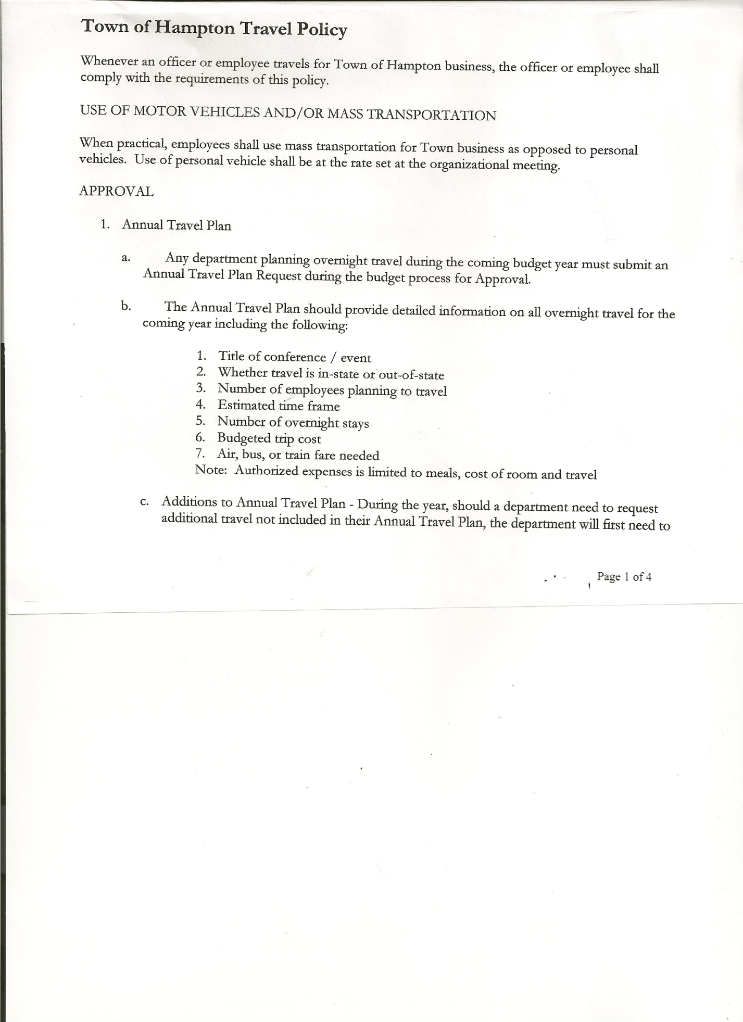
Michael Pietryka------------Councilman - absent
Bradley Perry --------------Councilman
Rebecca Jones---------------Town Clerk
Camilla Shaw----------------Deputy Town Clerk
Tyler McClure---------------Highway Superintendent

Planning Board Member (s):… Bonnie Hawley, Chair, and Matthew Pratt
Others present at the Town Hall: EJ Conzola (NY/VT Media Reporter), Artie Pratt and Deborah Weiss.

The Regular Meeting was called to order by Supervisor O’Brien at 7:30pm, followed by the Pledge of Allegiance. Location of Fire Exits was given. Quorum of board members present.

Supervisor O’Brien asked for a moment of silence in memory of Jack Ferguson

RESOLUTION NO. 18-2026
APPROVAL OF THE MINUTES
On a motion of Councilman Sady, seconded by Councilman Perry, the following resolution was ADOPTED: AYES 4 O’Brien, Sady, Taran, Perry
NAYS 0
ABSENT 1 Pietryka
RESOLVED, the Regular Town Board Meeting Minutes for January 15, 2026 are approved.

Dog Control Officer…..no report

Tax Collector Report….January 2026 monthly report is attached. The Town Clerk/Collector had Board Members review and sign bank reconciliation statements for the Tax Collector Account dated January 31st, 2026.

Bonnie Hawley, Chair Planning Board…. Continuing to work on Battery Energy Storage Systems law. Next meeting will be March 11, 2026 @7:00 at the Town Hall. The Planning Board is also having a meeting on March 18th, 2026 from 7 to 9pm at Milestone Golf Course, County Route 18, to gather information from residents for their vision of our town for a Comprehensive Plan.

TOWN BOARD MEETING
FEBRUARY 19, 2026 PAGE 2

Tyler McClure, Highway Superintendent…submitted his report, copy of which is attached.

SUPERVISOR’S REPORT/COUNTY UPDATES/COMMUNICATIONS

RESOLUTION NO. 19-2026
APPROVAL OF THE SUPERVISOR’S MONTHLY REPORT
On a motion of Councilman Sady, seconded by Councilwoman Taran, the following resolution was ADOPTED: AYES 4 O’Brien, Sady, Taran, Perry
NAYS 0
ABSENT 1 Pietryka
RESOLVED that, the Supervisor’s Monthly report be accepted as amended and submitted for JANUARY.
ACCOUNT 01/01/26 Receipts Disbursed 01/31/26
Citizens Cemetery $ 3,021.62 $ .13 $ 0.00 $ 3,021.75
Citizens Total $ 3,021.62 $ .13 $ 0.00 $ 3,021.75

GFNB Fire, Trust & Agency $ 0.00 $ 0.00 $ 0.00 $ 0.00
GFNB Fire, Trust & Agency ICS $ 32,859.00 $ 0.00 $ 32,859.00 $ 0.00
GFNB Health Insurance $ 2,591.23 $ 0.00 $ 0.00 $ 2,591.23
GFNB Trust & Agency $ 3,390.30 $ 4,327.80 $ 4,327.80 $ 3,390.30
GFNB General Fund $ 1,209.78 $ 68,632.32 $ 68,044.22 $ 1,797.88
GFNB General Fund ICS $ 42,819.40 $ 25,118.54 $ 4,000.00 $ 63,937.94
GFNB Total $ 82,869.71 $ 98,078.66 $109,231.02 $ 71,717.35

GFNB Highway Fund $ 2,209.69 $517,515.85 $345,325.68 $ 174,399.86
GFNB Highway Fund ICS $ 113,726.86 $240,651.45 $ 3000.00 $ 351,378.31
GFNB Capital Reserve $ 2,217.52 $ 90,000.00 $ 90,000.00 $ 2,217.52
GFNB Capital Reserve ICS $ 171,905.26 $ 90,486.47 $ 0.00 $ 262,391.73
GFNB Total $ 290,059.33 $938,653.77 $438,325.68 $ 790,387.42

TOTALS $375,950.66 $1,036,732.56 $547,556.70 $ 865,126.52
All Board Members present signed Supervisor’s Report.

RESOLUTION NO. 20-2026
END OF YEAR AUDIT FOR CHIEF FISCAL OFFICER
On a motion of Councilwoman Taran, seconded by Councilman Sady, the following resolution was ADOPTED: AYES 3 Sady, Taran, Perry
NAYS 0
ABSENT 1 Pietryka
ABSTAIN 1 O’Brien
RESOLVED, to accept the Chief Fiscal Officer (Bookkeeper) Audit for 2025.

TOWN BOARD MEETING
FEBRUARY 19, 2026 PAGE 3

NEW BUSINESS
Supervisor O’Brien forwarded information to Board members regarding necessary changes to our community’s Local Law for Flood Damage Prevention. These changes are prompted by the completion of a new FEMA Flood Insurance Study (FIS) and associated Flood Insurance Rate Map (FIRM) panels. To maintain eligibility in the National Flood Insurance Program (NFIP), it is necessary to adopt the updated FIS and FIRMs into our local floodplain management regulations. The Town Board will discuss further at the March meeting.

PUBLIC/COUNCIL COMMENTS
Deb Weiss…. March 11th at 7pm at the Village of Granville Offices
Devin Lander, who is running for State Senator in District 43 will be there. Looking to meet residents that live in District 43.

RESOLUTION NO. 21-2026
AUDIT OF CLAIMS
On a motion of Councilwoman Taran, seconded by Councilman Sady the following resolution was ADOPTED : AYES 4 O’Brien, Sady, Taran, Perry
NAYS 0
ABSENT 1 Pietryka
RESOLVED that the bills have been reviewed by the Town Board and are authorized for payment in the following amounts.
General Fund No.18 through No. 35 $ 18,232.76
Highway Fund No.11 through No. 26 $ 13,927.58
Total both funds $ 32,160.34

The Town Clerk’s report for January 2026 was submitted to the Board. The Town Clerk had Board Members review and sign bank reconciliation statements for the Town Clerk Account and Special Town Clerk Account dated January 31st, 2026 from Citizens Bank and Community Bank. Town Clerk is switching banks from Citizens Bank to Community Bank.

RESOLUTION NO. 22-2026
MEETING ADJOURNED
On a motion of Councilman Perry, seconded by Councilman Sady the following resolution was ADOPTED: AYES 4 O’Brien, Sady, Taran, Perry
NAYS 0
ABSENT 1 Pietryka
RESOLVED that the meeting adjourned at 8:06pm.

Respectfully submitted,

Rebecca S. Jones, RMC
Town Clerk

