REGULAR MEETING
MARCH 19, 2026

The Regular Meeting of the Town Board of the Town of Hampton, County of Washington and the State of New York was held at the Town Hall, 2629 State Route 22A, Hampton, New York, on the 19th day of March 2026.

PRESENT: David K. O’Brien-----------Supervisor
Donald Sady---------------- Councilman - absent
Tamme Taran---------------Councilwoman
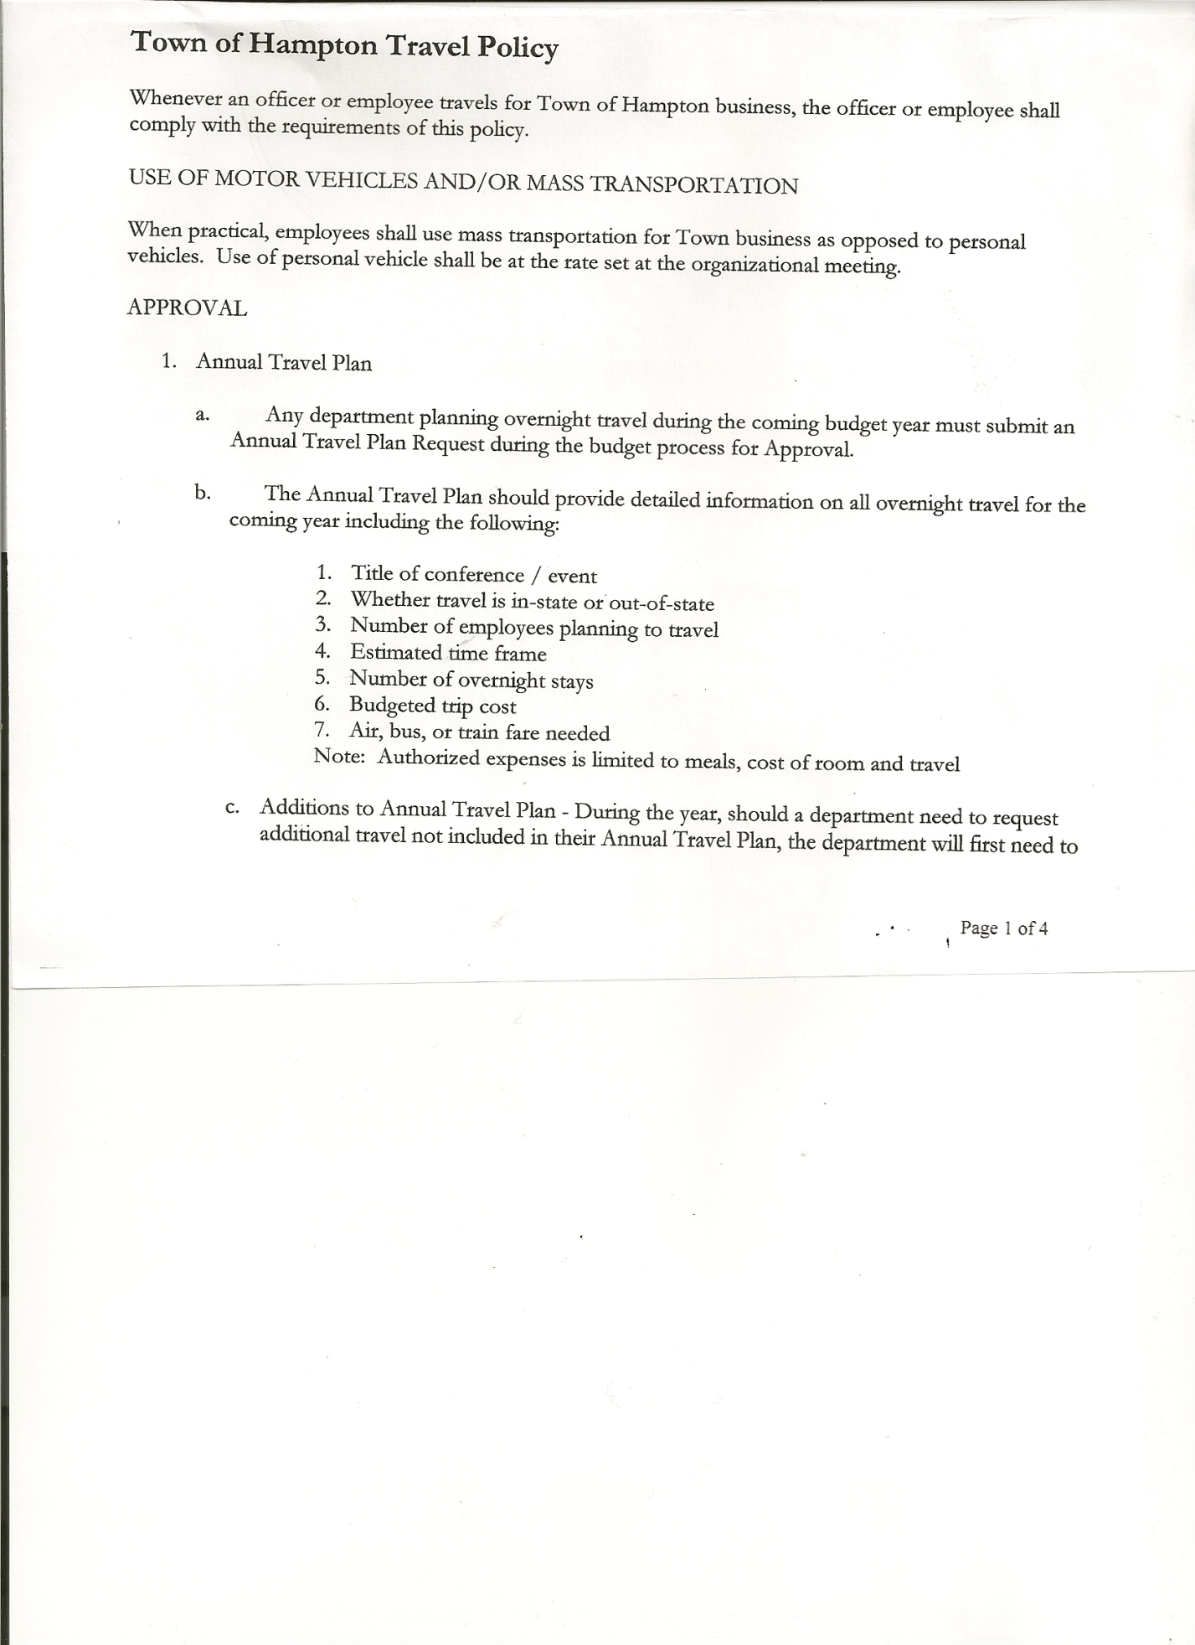
Michael Pietryka------------Councilman
Bradley Perry --------------Councilman
Rebecca Jones---------------Town Clerk
Camilla Shaw----------------Deputy Town Clerk - absent
Tyler McClure---------------Highway Superintendent

Planning Board Member (s):… Bonnie Hawley, Chair, and Matthew Pratt
Others present at the Town Hall: EJ Conzola (NY/VT Media Reporter)

The Regular Meeting was called to order by Supervisor O’Brien at 7:30pm, followed by the Pledge of Allegiance. Location of Fire Exits was given. Quorum of board members present.

RESOLUTION NO. 23-2026
APPROVAL OF THE MINUTES
On a motion of Councilwoman Taran, seconded by Councilman Perry, the following resolution was ADOPTED: AYES 3 O’Brien, Taran, Perry
NAYS 0
ABSENT 1 Sady
ABSTAIN 1 Pietryka
RESOLVED, the Regular Town Board Meeting Minutes for February 19, 2026 are approved.

Dog Control Officer…..Supervisor O’Brien reported that there was a dog bite and the dog was being quarantined for 10 days.

Tax Collector Report….February 2026 monthly report is attached. 117 Second Notice letters for unpaid taxes were sent out on March 2nd. The Town Clerk/Collector had Board Members review and sign bank reconciliation statements for the Tax Collector Account dated February 28th, 2026.

Bonnie Hawley, Chair Planning Board….The Planning Board held a meeting on March 18th, 2026 from 7 to 9pm at Milestone Golf Course, County Route 18, to gather information from residents for their vision of our town for a Comprehensive Plan. Fourteen people attended.
Attached is a list of the priorities for the vision. The next Planning Board meeting will be April 8th at 7:00pm at the Town Hall.

Tyler McClure, Highway Superintendent…submitted his report, copy of which is attached.

TOWN BOARD MEETING
MARCH 19, 2026 PAGE 2

SUPERVISOR’S REPORT/COUNTY UPDATES/COMMUNICATIONS

RESOLUTION NO. 24-2026
APPROVAL OF THE SUPERVISOR’S MONTHLY REPORT
On a motion of Councilwoman Taran, seconded by Councilman Pietryka, the following resolution was ADOPTED: AYES 4 O’Brien, Pietryka, Taran, Perry
NAYS 0
ABSENT 1 Sady
RESOLVED that, the Supervisor’s Monthly report be accepted as amended and submitted for FEBRUARY.
ACCOUNT 02/01/26 Receipts Disbursed 02/28/26
Citizens Cemetery $ 3,021.75 $ .13 $ 0.00 $ 3,021.88
Citizens Total $ 3,030.75 $ .13 $ 0.00 $ 3,021.88

GFNB Fire, Trust & Agency $ 0.00 $ 69,073.00 $ 68,500.00 $ 573.00
GFNB Fire, Trust & Agency ICS $ 0.00 $ 68,500.00 $ 0.00 $ 68,500.00
GFNB Health Insurance $ 2,591.23 $ 0.00 $ 0.00 $ 2,591.23
GFNB Trust & Agency $ 3,390.30 $ 4,327.80 $ 4,327.80 $ 3,390.30
GFNB General Fund $ 1,797.88 $ 36,533.20 $ 20,247.70 $ 18,083.38
GFNB General Fund ICS $ 63,937.94 $ 14,345.26 $ 21,000.00 $ 57,283.20
GFNB Total $ 71,717.35 $192,779.26 $114,075.50 $ 150,421.11

GFNB Highway Fund $ 174,399.86 $ 30,000.00 $181,714.97 $ 22,684.89
GFNB Highway Fund ICS $ 351,378.31 $ 96,146.05 $ 30,000.00 $ 417,524.36
GFNB Capital Reserve $ 2,217.52 $ 33,000.00 $ 33,000.00 $ 2,217.52
GFNB Capital Reserve ICS $ 262,391.73 $ 722.21 $ 0.00 $ 263,113.94
GFNB Total $ 790,387.42 $159,868.26 $244,714.97 $705,540.71

TOTALS $ 865,135.52 $352,647.65 $358,790.47 $858,983.70
All Board Members present signed Supervisor’s Report.

RESOLUTION NO. 25-2026
AUDIT OF CLAIMS
On a motion of Councilwoman Taran, seconded by Councilman Perry the following resolution was ADOPTED : AYES 4 O’Brien, Pietryka, Taran, Perry
NAYS 0
ABSENT 1 Sady
RESOLVED that the bills have been reviewed by the Town Board and are authorized for payment in the following amounts.
General Fund No.36 through No. 46 $ 5,418.36
Highway Fund No.27 through No. 36 $ 5,875.99
Total both funds $ 11,294.35

TOWN BOARD MEETING
MARCH 19, 2026 PAGE 3

The Town Clerk’s report for February 2026 was submitted to the Board. The Town Clerk had Board Members review and sign bank reconciliation statements for the Town Clerk Account and Special Town Clerk Account dated February 28th, 2026 from Citizens Bank and Community Bank. Last month for statements from Citizens Bank.

RESOLUTION NO. 26-2026
EXECUTIVE SESSION
On a motion of Councilwoman Taran, seconded by Councilman Perry the following resolution was ADOPTED: AYES 4 O’Brien, Pietryka, Taran, Perry
NAYS 0
ABSENT 1 Sady
RESOLVED the Town Board entered into Executive Session at 7:59pm to discuss ongoing litigation.

RESOLUTION NO. 27-2026
RETURN TO REGULAR SESSION
On a motion of Councilwoman Taran, seconded by Councilman Perry the following resolution was ADOPTED: AYES 4 O’Brien, Pietryka, Taran, Perry
NAYS 0
ABSENT 1 Sady
RESOLVED the Town Board returned to regular session at 8:29pm.

RESOLUTION NO. 28-2026
MEETING ADJOURNED
On a motion of Councilwoman Taran, seconded by Councilman Pietryka the following resolution was ADOPTED: AYES 4 O’Brien, Pietryka, Taran, Perry
NAYS 0
ABSENT 1 Sady
RESOLVED that the meeting adjourned at 8:29pm.

Respectfully submitted,

Rebecca S. Jones, RMC
Town Clerk

