REGULAR MEETING
AUGUST 20, 2026

The Regular Meeting of the Town Board of the Town of Hampton, County of Washington and the State of New York was held at the Town Hall, 2629 State Route 22A, Hampton, New York, on the 20th day of August 2026.

PRESENT: David K. O’Brien-----------Supervisor
Donald Sady---------------- Councilman
Tamme Taran---------------Councilwoman-absent
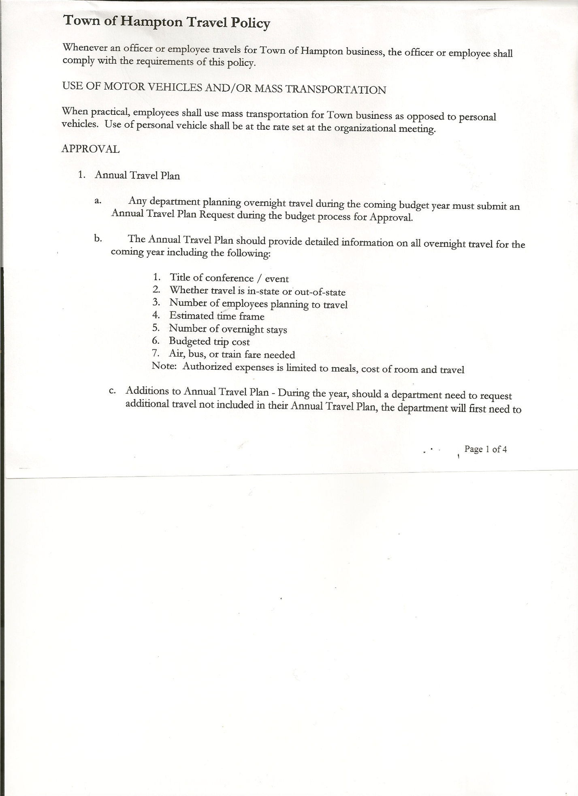
Michael Pietryka------------Councilman
Bradley Perry --------------Councilman
Rebecca Jones---------------Town Clerk
Camilla Shaw----------------Deputy Town Clerk
Tyler McClure---------------Highway Superintendent-absent

Planning Board Member (s):… Bonnie Hawley, Chair, and Matthew Pratt
Others present at the Town Hall: EJ Conzola (NY/VT Media Reporter), Tiffany Mason, Artie Pratt and Leonard Reed.

The Regular Meeting was called to order by Supervisor O’Brien at 7:30pm, followed by the Pledge of Allegiance. Location of Fire Exits was given. Quorum of board members present.

RESOLUTION NO. 60-2026
APPROVAL OF THE MINUTES
On a motion of Councilman Sady, seconded by Councilman Perry, the following resolution
was ADOPTED: AYES 4 O’Brien, Sady, Pietryka, Perry
NAYS 0
ABSENT 1 Taran
RESOLVED, the Regular Town Board Meeting Minutes for July 16, 2026 are approved.

Tiffany Mason needed a new mylar map signed, the previous mylar was damaged and unable to be filed with the County. Board members present signed the new mylar.

Dog Control Officer…..no report

Tax Collector Report…. Zero balance. The Town Clerk/Collector had Board Members review and sign bank reconciliation statements for the Tax Collector Account dated July 31, 2026.

Bonnie Hawley, Chair Planning Board….Planning Board Meeting was held August 12, 2026, copy of the minutes is attached. Next meeting will be September 9, 2026 @7:00pm at the Town Hall

Tyler McClure, Highway Superintendent…submitted his report, copy of which is attached.
In Tyler’s absence, Supervisor O’Brien read the submitted report.

TOWN BOARD MEETING
AUGUST 20, 2026 PAGE 2

SUPERVISOR’S REPORT/COUNTY UPDATES/COMMUNICATIONS

RESOLUTION NO. 61-2026
APPROVAL OF THE SUPERVISOR’S MONTHLY REPORT
On a motion of Councilman Pietryka, seconded by Councilman Sady, the following resolution was ADOPTED: AYES 4 O’Brien, Sady, Pietryka, Perry
NAYS 0
ABSENT 1 Taran
RESOLVED that, the Supervisor’s Monthly report be accepted as submitted for JULY.
ACCOUNT 07/01/26 Receipts Disbursed 07/31/26
Citizens Cemetery $ 4,272.49 $ 1581.92 $ 5150.88 $ 703.53
Citizens Total $ 4,272.49 $ 1581.92 $ 5150.88 $ 703.53

GFNB Fire, Trust & Agency $ 35,109.50 $ 0.00 $ 34,536.50 $ 573.00
GFNB Fire, Trust & Agency ICS $ 33,963.50 $ 0.00 $ 0.00 $ 33,963.50
GFNB Health Insurance $ 2,591.23 $ 0.00 $ 0.00 $ 2,591.23
GFNB Trust & Agency $ 7,384.38 $ 5,222.67 $ 3,989.80 $ 8,617.25
GFNB General Fund $ 6,278.62 $ 13,629.98 $ 16,511.89 $ 3,396.71
GFNB General Fund ICS $ 43,298.58 $ 5,736.20 $ 3,500.00 $ 45,534.78
GFNB Total $128,625.81 $ 24,588.85 $ 58,538.19 $ 94,676.47

GFNB Highway Fund $ 6,997.19 $ 15,000.00 $ 19,610.85 $ 2,386.34
GFNB Highway Fund ICS $ 109,685.54 $ 282.17 $ 15,000.00 $ 94,967.71
GFNB Capital Reserve $ 192.52 $ 0.00 $ 0.00 $ 192.52
GFNB Capital Reserve ICS $ 264,554.35 $ 788.39 $ 0.00 $ 265,342.74
GFNB Total $ 381,429.60 $ 16,070.56 $ 36,610.85 $ 362,889.31

TOTALS $ 514,327.90 $ 42,241.33 $ 98,299.92 $458,269.31
All Board Members present signed Supervisor’s Report.
Board members liked the reconciliation statements with the Supervisor’s report.

OLD BUSINESS
Article 7 Main Street Express Final Judgement Resolutions
RESOLUTION NO. 62-2026
MOTION BY: Councilman Donald Sady
SECONDED BY: Councilman Bradley Perry

RESOLUTION APPROVING THE STIPULATED FINAL JUDGMENT RELATIVE TO THE MAIN STREET EXPRESS v. AREK GORDON, ASSESSOR BEARING
INDEX NUMBER - EC2025-39606

WHEREAS, THE MAIN STREET EXPRESS, Petitioner, commenced actions against the Town of Hampton, under Article 7 of the Real Property Tax Law in the Washington County Supreme Court pertaining to property located in the Town of Hampton, New York, bearing tax map identification numbers 71.-1-29.1, 71.3-2-2, 71.3-3-2, 71.3-3-3, 71.3-3-7, and 71.3-3-15; and

WHEREAS, the parties have come to an agreement concerning the assessed valuation of the real property contained in the proceedings as it is in the interest of all parties to resolve this proceeding at this time and in this manner to avoid escalating costs associated with protracted litigation; and

TOWN BOARD MEETING
AUGUST 20, 2026 PAGE 3

WHEREAS, it is the desire of the Town of Hampton to authorize their legal counsel on this matter, Meyer, Fuller & Stockwell, PLLC to sign and accept the Stipulation of Settlement and Order relative to the reduction of assessment in accordance with the proposed Stipulation of Settlement and Order, attached hereto and made apart hereof pertaining to property located in the Town of Hampton, New York, bearing tax map identification number 71.-1-29.1, 71.3-2-2, 71.3-3-2, 71.3-3-3, 71.3-3-7, and 71.3-3-15.

NOW THEREFORE BE IT:

RESOLVED, that Meyer, Fuller & Stockwell, PLLC is authorized to execute any and all documents pertaining to the settlement of the Article 7 petition reducing the assessment on property bearing tax identification number: 71.-1-29.1, 71.3-2-2, 71.3-3-2, 71.3-3-3, 71.3-3-7, and 71.3-3-15, in accordance with the RPTL Section 727 to establish the assessment rates for the ensuing years and based on the terms contained therein.

BE IT FURTHER RESOLVED, that this resolution shall take effect immediately.

DATED: August 20, 2026 Supervisor O’Brien AYE
Councilman Sady AYE
Councilman Pietryka AYE
Councilman Perry AYE
Councilwoman Taran ABSENT

RESOLUTION NO. 63-2026
MOTION BY: Councilman Donald Sady
SECONDED BY: Councilman Bradley Perry

RESOLUTION APPROVING THE STIPULATED FINAL JUDGMENT RELATIVE TO THE MAIN STREET EXPRESS v. AREK GORDON, ASSESSOR BEARING
INDEX NUMBER - EC2025-39611

WHEREAS, THE MAIN STREET EXPRESS, Petitioner, commenced actions against the Town of Hampton, under Article 7 of the Real Property Tax Law in the Washington County Supreme Court pertaining to property located in the Town of Hampton, New York, bearing tax map identification numbers 71.3-2-1, 71.3-2-3, 71.3-2-4, 71.3-2-5, 71.3-2-6, 71.3-3-4, 71.3-3-5, and 71.3-3-6; and

WHEREAS, the parties have come to an agreement concerning the assessed valuation of the real property contained in the proceedings as it is in the interest of all parties to resolve this proceeding at this time and in this manner to avoid escalating costs associated with protracted litigation; and

WHEREAS, it is the desire of the Town of Hampton to authorize their legal counsel on this matter, Meyer, Fuller & Stockwell, PLLC to sign and accept the Stipulation of Settlement and Order relative to the reduction of assessment in accordance with the proposed Stipulation of Settlement and Order, attached hereto and made apart hereof pertaining to property located in the Town of Hampton, New York, bearing tax map identification number 71.3-2-1, 71.3-2-3, 71.3-2-4, 71.3-2-5, 71.3-2-6, 71.3-3-4, 71.3-3-5, and 71.3-3-6.

TOWN BOARD MEETING
AUGUST 20, 2026 PAGE 4

NOW THEREFORE BE IT:

RESOLVED, that Meyer, Fuller & Stockwell, PLLC is authorized to execute any and all documents pertaining to the settlement of the Article 7 petition reducing the assessment on property bearing tax identification number: 71.3-2-1, 71.3-2-3, 71.3-2-4, 71.3-2-5, 71.3-2-6, 71.3-3-4, 71.3-3-5, and 71.3-3-6, in accordance with the RPTL Section 727 to establish the assessment rates for the ensuing years and based on the terms contained therein.

BE IT FURTHER RESOLVED, that this resolution shall take effect immediately.

DATED: August 20, 2026 Supervisor O’Brien AYE
Councilman Sady AYE
Councilman Pietryka AYE
Councilman Perry AYE
Councilwoman Taran ABSENT

Salt Shed Grant Application…Total cost of project is $615,000.00; Grant to cover $492,000.00; Town share is $123,000.00 + $20,000.00 (in kind services).
NEW BUSINESS
Washington County Hazard Mitigation Plan….the following resolution is adopting the 2026 Washington County Hazard Mitigation Plan
RESOLUTION NO. 64-2026
MOTION BY: Councilman Michael Pietryka
SECONDED BY: Councilman Donald Sady

A RESOLUTION OF THE TOWN OF HAMPTON ADOPTING THE 2026 WASHINGTON COUNTY HAZARD MITIGATION PLAN

WHEREAS the Town Board recognizes the threat that hazards pose to people and property within the Town of Hampton; and
WHEREAS the Town of Hampton has prepared a multi-hazard mitigation plan, hereby known as 2026 Washington County Hazard Mitigation Plan in accordance with the Disaster Mitigation Act of 2000; and
WHEREAS 2026 Washington County Hazard Mitigation Plan identifies mitigation goals and actions to reduce or eliminate long-term risk to people and property in Town of Hampton from the impacts of future hazards and disasters; and
WHEREAS adoption by the Town Board demonstrates their commitment to hazard mitigation and achieving the goals outlined in the 2026 Washington County Hazard Mitigation Plan.
NOW THEREFORE, BE IT RESOLVED BY THE Town Board of Hampton, New York, THAT:
Section 1. In accordance with local rule for adopting resolutions, the Town Board adopts the 2026 Washington County Hazard Mitigation Plan. This plan, approved by the community, may be edited or amended after submission for review, but will not require the community to re-adopt any further iterations. This only applies to this specific plan and does not absolve the community from updating the plan in 5 years.
ADOPTED by a vote of 4 in favor and 1 absent, this 20th day of August, 2026.
By: _________________________________
David O’Brien, Supervisor
ATTEST: By: _________________________________
Rebecca Jones, Town Clerk
APPROVED AS TO FORM: By: _________________________________
Rebecca Jones, Town Clerk

TOWN BOARD MEETING
AUGUST 20, 2026 PAGE 5

Budget Forms handed out, need to be back to Supervisor by 9/5/2026.

RESOLUTION NO. 65-2026
RETIREMENT CALENDAR FOR COUNCILWOMAN TARAN
On a motion of Councilman Sady, seconded by Councilman Perry, the following resolution
was ADOPTED: AYES 4 O’Brien, Sady, Pietryka, Perry
NAYS 0
ABSENT 1 Taran
RESOLVED, to accept (3) months Records of Activities from Tamme Taran, Councilwoman for Retirement purposes.
RESOLUTION NO. 66-2026
STANDARD WORKDAY and REPORTING RESOLUTION
On a motion of Councilman Sady, seconded by Councilman Perry, the following resolution
was ADOPTED: AYES 4 O’Brien, Sady, Pietryka, Perry
NAYS 0
ABSENT 1 Taran
RESOLVED, that the Standard Workday and Reporting Resolution for Elected and Appointed Officials (RS2417-A) be approved. Copy is attached.

The people that were residing at Flubberbuster’s on State Route 4, are not there anymore. The building, per the County, is a single-family home with commercial space.

RESOLUTION NO. 67-2026
AUDIT OF CLAIMS
On a motion of Councilman Pietryka, seconded by Councilman Perry the following resolution was ADOPTED : AYES 4 O’Brien, Sady, Pietryka, Perry
NAYS 0
ABSENT 1 Taran
RESOLVED that the bills have been reviewed by the Town Board and are authorized for payment in the following amounts.
General Fund No.100 through No.111 $ 3,909.44
Highway Fund No. 89 through No.100 $ 11,485.08
Total all funds $ 15,394.52

The Town Clerk’s report for July 2026 was submitted to the Board. The Town Clerk had Board Members review and sign bank reconciliation statements for the Town Clerk Account and Special Town Clerk Account dated July 31st, 2026 from Community Bank.

RESOLUTION NO. 68-2026
MEETING ADJOURNED
On a motion of Councilman Pietryka, seconded by Councilman Sady the following resolution was ADOPTED: AYES 4 O’Brien, Sady, Pietryka, Perry
NAYS 0
ABSENT 1 Taran
RESOLVED that the meeting adjourned at 8:09pm.

Respectfully submitted,

Rebecca S. Jones, RMC
Town Clerk

