REGULAR MEETING
SEPTEMBER 17, 2026

The Regular Meeting of the Town Board of the Town of Hampton, County of Washington and the State of New York was held at the Town Hall, 2629 State Route 22A, Hampton, New York, on the 17th day of September 2026.

PRESENT: David K. O’Brien-----------Supervisor
Donald Sady---------------- Councilman-absent
Tamme Taran---------------Councilwoman
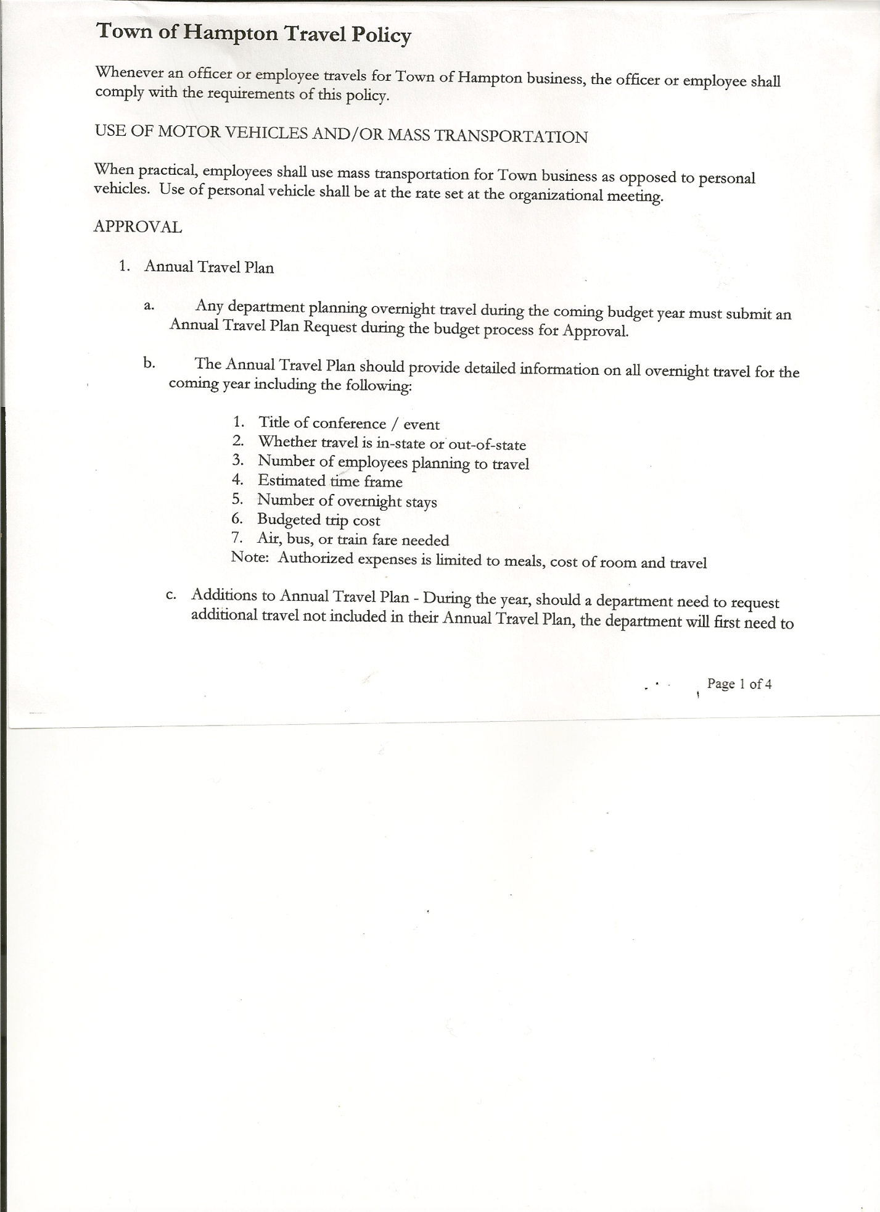
Michael Pietryka------------Councilman
Bradley Perry --------------Councilman
Rebecca Jones---------------Town Clerk
Camilla Shaw----------------Deputy Town Clerk
Tyler McClure---------------Highway Superintendent

Planning Board Member (s):… Bonnie Hawley, Chair, and Matthew Pratt
Others present at the Town Hall: Artie Pratt and Leonard Reed.

The Regular Meeting was called to order by Supervisor O’Brien at 7:30pm, followed by the Pledge of Allegiance. Location of Fire Exits was given. Quorum of board members present.

RESOLUTION NO. 69-2026
APPROVAL OF THE MINUTES
On a motion of Councilman Pietryka, seconded by Councilman Perry, the following resolution
was ADOPTED: AYES 4 O’Brien, Taran, Pietryka, Perry
NAYS 0
ABSENT 1 Sady
RESOLVED, the Regular Town Board Meeting Minutes for August 20, 2026 are approved.

Dog Control Officer…..incident on Hills Pond Road, troopers were called. Fight involving four pitbulls. Two were shot and the other two quarantined.

Tax Collector Report…. Zero balance. The Town Clerk/Collector had Board Members review and sign bank reconciliation statements for the Tax Collector Account dated August 31, 2026.

Bonnie Hawley, Chair Planning Board….Planning Board Meeting was held September 9, 2026 Members took parts of the Comp Plan to read over. Next meeting will be October 14, 2026 @7:00pm at the Town Hall

Tyler McClure, Highway Superintendent…submitted his report, copy of which is attached.

TOWN BOARD MEETING
SEPTEMBER 17, 2026 PAGE 2

SUPERVISOR’S REPORT/COUNTY UPDATES/COMMUNICATIONS

RESOLUTION NO. 70-2026
APPROVAL OF THE SUPERVISOR’S MONTHLY REPORT
On a motion of Councilman Pietryka, seconded by Councilwoman Taran, the following resolution was ADOPTED: AYES 4 O’Brien, Taran, Pietryka, Perry
NAYS 0
ABSENT 1 Sady
RESOLVED that, the Supervisor’s Monthly report be accepted as submitted for AUGUST.
ACCOUNT 08/01/26 Receipts Disbursed 08/31/26
Citizens Cemetery $ 703.53 $ 1,265.04 $ 765.00 $ 1,203.57
Citizens Total $ 703.53 $ 1,265.04 $ 765.00 $ 1,203.57

GFNB Fire, Trust & Agency $ 573.00 $ 0.00 $ 0.00 $ 573.00
GFNB Fire, Trust & Agency ICS $ 33,963.50 $ 0.00 $ 0.00 $ 33,963.50
GFNB Health Insurance $ 2,591.23 $ 0.00 $ 0.00 $ 2,591.23
GFNB Trust & Agency $ 8,617.25 $ 3,703.07 $ 5,222.67 $ 7,097.65
GFNB General Fund $ 3,396.71 $ 3,992.41 $ 5,789.25 $ 1,599.87
GFNB General Fund ICS $ 45,534.78 $ 236.54 $ 3,000.00 $ 42,771.32
GFNB Total $ 94,676.47 $ 7,932.02 $ 14,011.92 $ 88,596.57

GFNB Highway Fund $ 2,386.34 $ 26,024.99 $ 20,740.97 $ 7,670.36
GFNB Highway Fund ICS $ 94,967.71 $ 213.25 $ 26,000.00 $ 69,180.96
GFNB Capital Reserve $ 192.52 $ 0.00 $ 0.00 $ 192.52
GFNB Capital Reserve ICS $ 265,342.74 $ 820.45 $ 0.00 $ 266,163.19
GFNB Total $ 362,889.31 $ 27,058.69 $ 46,740.97 $ 343,207.03

TOTALS $ 458,269.31 $ 36,255.75 $ 61,517.89 $433,007.17
All Board Members present signed Supervisor’s Report.

OLD BUSINESS
Battery Storage Law is going to be a separate law, rather than incorporating it in the Site Plan Review Law.
RESOLUTION NO. 71-2026
MOTION BY: Councilwoman Tamme Taran
SECONDED BY: Councilman Bradley Perry

RESOLUTION INTRODUCING A PROPOSED LOCAL LAW
REGULATING THE LOCATION OF BATTERY ENERGY STORAGE SYSTEMS
IN THE TOWN OF HAMPTON

WHEREAS, pursuant to Article I, section 19 and Article IX of the New York State Constitution, together with Articles 2 and 3 of the Municipal Home Rule Law, the Town Board of the Town of Hampton (the “Town”) has the authority to adopt local laws that promote health, safety, and general welfare of the Town of Hampton; and

WHEREAS, a sudden increase in developmental pressures within the Town of Hampton with respect to development of large scale solar energy generating facilities and the related battery energy storage systems have raised the prospect that the existing Site Plan Review Local Law may not be adequate for the review of the impacts and mitigation of the consequences of such uses and the approval thereof; and

TOWN BOARD MEETING
SEPTEMBER 17, 2026 PAGE 3

WHEREAS, commercial battery energy storage systems pose a unique safety hazard with regard to the technology used in such batteries; and

WHEREAS, a proposed local law regulating the location of battery energy storage systems in the Town of Hampton has been prepared to address the concerns; and

WHEREAS, the Town Board is desirous of proceeding with the review and consideration of this proposed Hampton.

NOW, THEREFORE BE IT RESOLVED THAT:

Section 1. The proposed local law regulating the location of battery energy storage systems in the Town of Hampton is hereby introduced. A public hearing shall be noticed and held by the Town Board on October 15, 2026 at 7:00 p.m. to consider the proposed local law. Copies of the Local Law shall be available at the Town Clerk’s office for review.

Section 2. The Town Clerk is hereby directed to publish and post the requisite public hearing notices in accordance with the law.

Section 3. This resolution shall take effect immediately.
DATED: September 17, 2026 Supervisor O’Brien AYE
Councilman Pietryka AYE
Councilwoman Taran AYE
Councilman Perry AYE
Councilman Sady ABSENT

RESOLUTION NO. 72-2026
PUBLIC HEARING-PROPOSED LOCAL LAW REGULATING THE LOCATION OF BATTERY ENERGY STORAGE SYSTEMS
On a motion of Councilman Perry, seconded by Councilwoman Taran, the following resolution was ADOPTED: AYES 4 O’Brien, Taran, Pietryka, Perry
NAYS 0
ABSENT 1 Sady
RESOLVED, to set a Public Hearing for October 15th, 2026 at 7:00pm on the proposed Local Law regarding regulating the location of battery energy storage systems in the Town of Hampton.

Discussed, reviewed and modified Tentative Budget

RESOLUTION NO. 73-2026
PUBLIC HEARING ON HAMPTON FIRE DISTRICT NUMBER
On a motion of Councilman Pietryka, seconded by Councilman Perry, the following resolution was ADOPTED: AYES 4 O’Brien, Taran, Pietryka, Perry
NAYS 0
ABSENT 1 Sady
RESOLVED, to set the Public Hearing to discuss the proposed contract between the Town on behalf of the Town of Hampton Fire Protection District and the Hampton Volunteer Fire Company for October 15th, 2026 at 7:05pm.

TOWN BOARD MEETING
SEPTEMBER 17, 2026 PAGE 4

RESOLUTION NO.74-2026
ADOPTION OF TENTATIVE BUDGET
On a motion of Councilman Pietryka, seconded by Councilman Perry, the following resolution was ADOPTED: AYES 4 O’Brien, Taran, Pietryka, Perry
NAYS 0
ABSENT 1 Sady
RESOLVED, that the 2027 Tentative Budget be adopted and becomes the 2027 Preliminary
Budget for the Town of Hampton.

RESOLUTION NO. 75-2026
PUBLIC HEARING ON PRELIMINARY BUDGET FOR 2027
On a motion of Councilwoman Taran, seconded by Councilman Pietryka, the following resolution was ADOPTED: AYES 4 O’Brien, Taran, Pietryka, Perry
NAYS 0
ABSENT 1 Sady
RESOLVED, to set the Public Hearing on the Preliminary Budget for 2027 for October 15th 2026 at 7:10pm.

RESOLUTION NO. 76-2026
BUDGET WORKSHOP
On a motion of Councilwoman Taran, seconded by Councilman Perry, the following resolution was ADOPTED: AYES 4 O’Brien, Taran, Pietryka, Perry
NAYS 0
ABSENT 1 Sady
RESOLVED, to set a Budget Workshop Meeting for Monday, October 5th, 2026 at 7:00pm.

PUBLIC COMMENT/COUNCIL COMMENT
County News….Buildings & Grounds and DPW may be combined, they are currently separated.

Supervisor is considering changing format of Supervisor’s Report. Will discuss with our accounting service.

RESOLUTION NO. 77-2026
AUDIT OF CLAIMS
On a motion of Councilwoman Taran, seconded by Councilman Pietryka the following resolution was ADOPTED : AYES 4 O’Brien, Taran, Pietryka, Perry
NAYS 0
ABSENT 1 Sady
RESOLVED that the bills have been reviewed by the Town Board and are authorized for payment in the following amounts.
General Fund No.112 through No.119 $ 2,336.24
Highway Fund No.101 through No.115 $ 6,878.16
Total all funds $ 9,214.40

The Town Clerk’s report for August 2026 was submitted to the Board. The Town Clerk had Board Members review and sign bank reconciliation statements for the Town Clerk Account and Special Town Clerk Account dated August 31st, 2026 from Community Bank.

TOWN BOARD MEETING
SEPTEMBER 17, 2026 PAGE 5

RESOLUTION NO. 78-2026
MEETING ADJOURNED
On a motion of Councilwoman Taran, seconded by Councilman Perry the following resolution was ADOPTED: AYES 4 O’Brien, Taran, Pietryka, Perry
NAYS 0
ABSENT 1 Sady
RESOLVED that the meeting adjourned at 8:35pm.

Respectfully submitted,

Rebecca S. Jones, RMC
Town Clerk

