SPECIAL MEETING
OCTOBER 5, 2026

A Special Meeting of the Town Board of the Town of Hampton, County of Washington and the State of New York was held at the Town Hall, 2629 State Route 22A, Hampton, New York on the 5th day of October, 2026.

PRESENT: David K. O’Brien-----------Supervisor
Tamme Taran----------------Councilwoman
Donald Sady-----------------Councilman - absent
Michael Pietryka------------Councilman
Bradley Perry--------------- Councilman
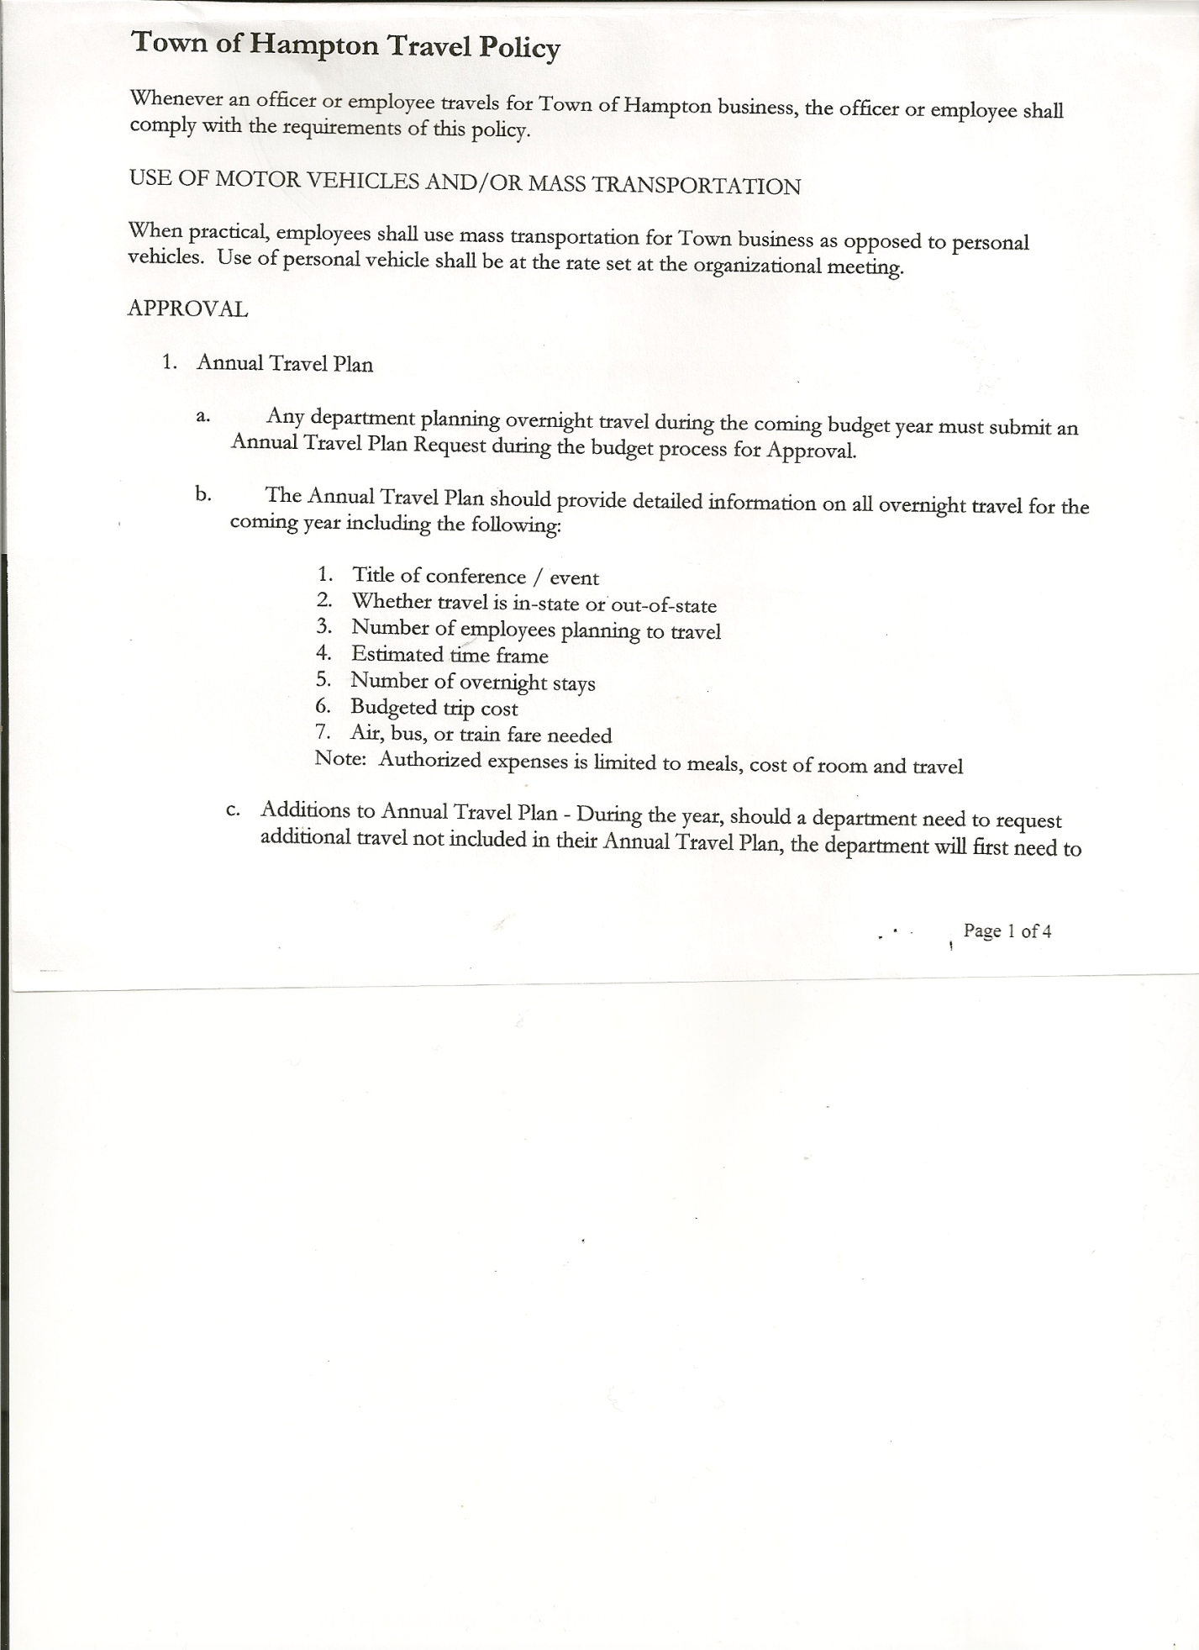
Rebecca Jones---------------Town Clerk

No one else was present.

The Special Meeting was called to order by Supervisor O’Brien at 7:00pm, followed by the Pledge of Allegiance. Location of Fire Exits were given. Quorum of board members present.

Town Clerk Jones read the Legal Notice of the Special Meeting (copy attached), which was published in the Sentinel-Times on 10/01/26.

Discussed some items on the Preliminary Budget, with suggestions/changes to be made at the Public Hearing on October 15th, 2026.

RESOLUTION NO. 79-2026
MEETING ADJOURNED
On a motion of Councilwoman Taran, seconded by Councilman Perry the following resolution was ADOPTED: AYES 4 O’Brien, Taran, Pietryka, Perry
NAYS 0
ABSENT 1 Sady
RESOLVED that the meeting adjourned at 7:34pm.

Respectfully submitted,

Rebecca S. Jones, RMC
Town Clerk

